Haitange N. Neliwa

Student no: 214042448

ID NO: 95101100315

Course name computer systems for health S

course code: csh710s

Contact number: 0814150235

due date of assignment: 17 May 2016

Assignment phase 1: Proposal

Email: neliwanelly0@gmail.com

Table of Contents

Table of Contents2

1. Introduction3
2. *Analysis*.*3*

*Problem Description………………………………………………………………………………………………………………………………3*

*The Goals* and *Objectives……………..……………………………………………………………………………………………….3*

*Solution Description……………………………………………………………………………………………………………………………..…3*

1. The Design……………………………………………………………………………………………………………………………………...4

Business Matrix Structure………………………………………………………………………………………………………………4

Context Diagram…………………………………………………………………………………………………………………………….4

Logical Design…………………………………………………………………………………………………………………………………5

Graphical Design…………………………………………………………………………………………………………………………….5

1. Introduction

Odimbwa is a small village geographically located at the northern part of Namibia in Omsati region, close to the Namibia-Angola borders. Odimbwa has a population of an estimated number of thirty thousand people. They do not have safety services such as a police station or a neighborhood watch, but Odimbwa has been fortunate enough to have electricity, a small market for business, a church, as well as a school that occupies for children in the 1st until the 10th grade.

When it comes to health facilities, Odimbwa has a small medical clinic with about 3-4 nurses and no medical doctor. The people of Odimbwa treasure this medical clinic as it is the nearest health facility for the people. Oshikuku and Oshakati state hospitals are the nearest options for patients if not Odimbwa clinic. These two state hospitals are very much distant from Odimbwa peoples, about 35-44 kilometers, which does not only take time but it also requires transport fee. The people of Odimbwa are humble and grateful of their health clinic, but it possess a lot of pressure on the nurses as they have to deal with a lot of patients.

1. Analysis

Problem Description

For 3-4 nurses to manage, care and cater for thirty thousand people, is not an easy task at all. Nurses at Odimbwa Clinic are feeling the weight of having to do administrative work and keeping patient records of their sicknesses, medications as well as their appointment dates. The major problem is that the people are many, and one cannot memorize the patient medical conditions, patient illnesses as well as their body temperature. Day to day operation such as administering a new patient have become time-consuming and possess much pressure on nurses because of the imbalanced ratio between nurses and patient. Odimbwa nurses need their work pressure to be reduced, it is not easy working with thirsty thousand people.

The Goals and Objectives

Namibia is a developing country, and as the land of the brave we have set a vision where our country will no longer led by corrupt people, a country with low or no poverty at all, no more hunger and starvation. As an informatitian/analyst with knowledge about the health sector, it is our duty and obligation to dedicate ourselves to be innovative and create systems that will contribute to Vision 2030.

This systems aims to reduce manual work done by the nurses. The system is to deliver simple administrative operational functionalities to Odimbwa clinic as well as other health facilities in the same situation where the ratio between a nurse and patients is largely exceeding. The objective is to implement a system that would result in better patient care while safeguarding privacy of information. Also, this system should be repeatedly redesign and implemented in order to serve the needs of patients and nurses. Upgrading the software to be better and better to serve the nation at large is the main goal.

Solution Description

In addition, people have requested that the number of nurses be increased, but it is not possible because the government is focusing on implementing health facilities in other places, which makes it difficult. In this case, making operational processes for nurses easier by giving them a fully-functioning administrative system would be a great alternative.

This system, Odimbwa Clinical Administrative System (OCAS), will cover two distinctive areas, the Patient function as well as the User function. Patient function covers all administrative functions to be performed by the user in order to deliver great service to patient this operations include:

-Adding a new patient to the system

-Checking a regular patient record

-Editing and modifying a patient record

In addition to “Patient “, each record will contain information the following record fields:

-Patient Name - Patient Surname - Patient ID - Parent/Representative Names -Sickness

-Description –Medication –Condition -As well as, Body temp

As for “User” function, the system user, once they are logged in will have access to:

-Adding new user to the system

- Viewing usual users

-Editing and modifying users

Also, the “User” table will have record of all users, with available information about:

-User Name

-Password

-User Position/Role

-User full Names

1. Design

Business Matrix Structure

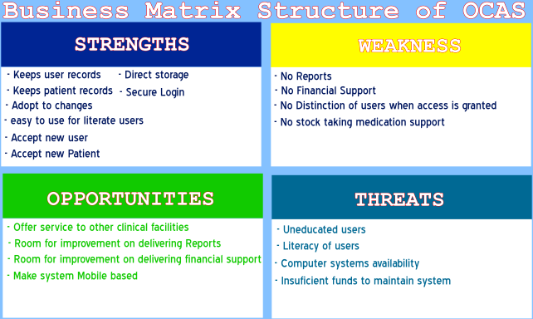

Context Diagram

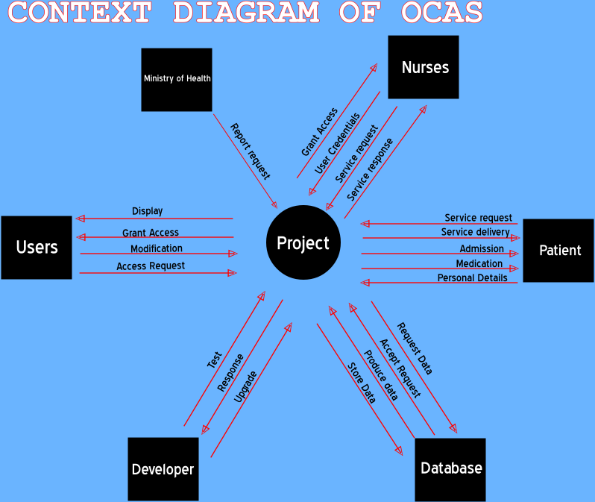

Logical Design

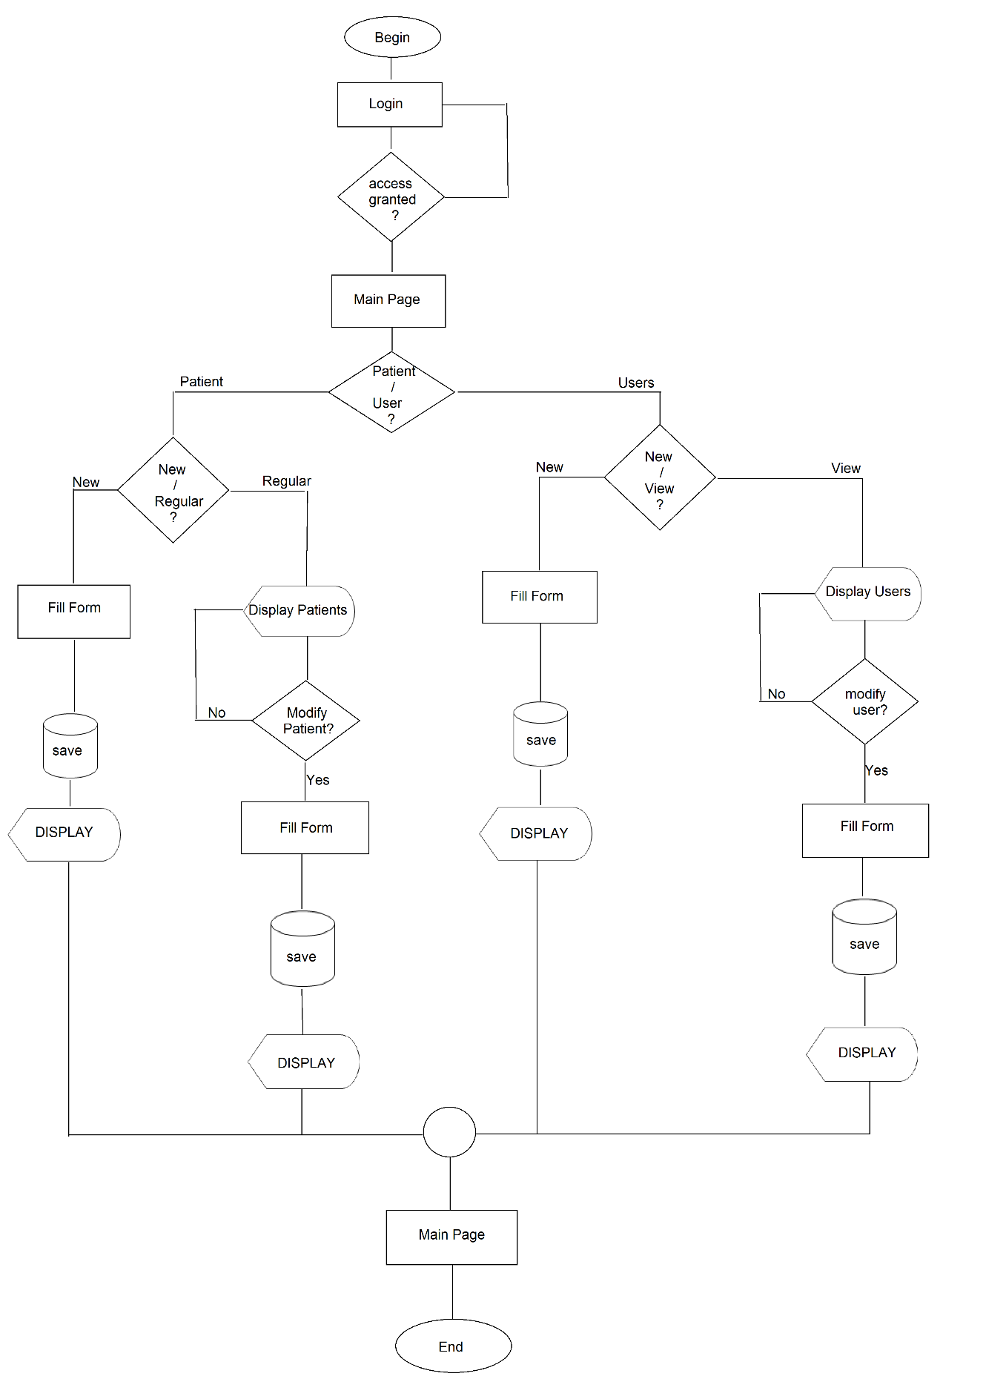

Graphical Design

1. Login page

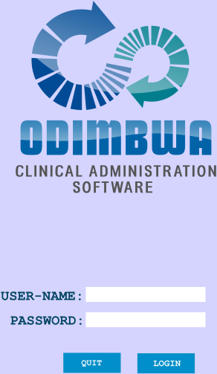

1. Home page after Access has been granted

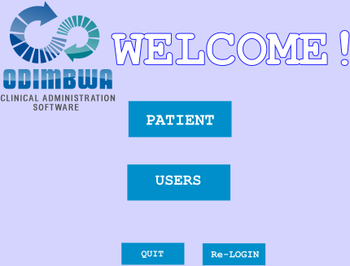

1. Patient

3.1 Patient Head page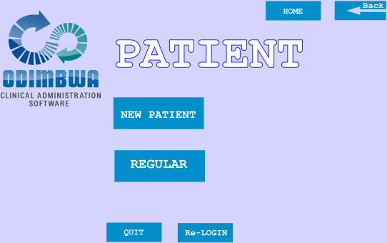

3.2 New Patient

3.2.1 Patient Fill Form

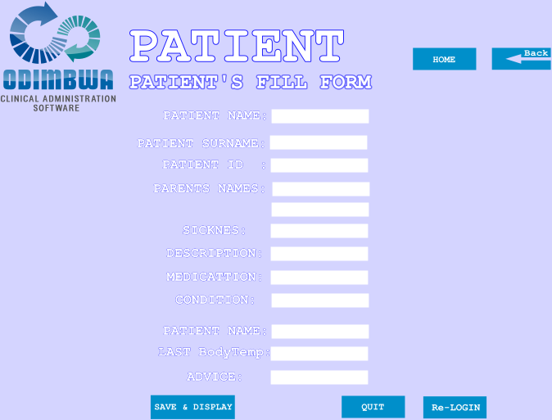

3.3 Regular

3.3.1 Display

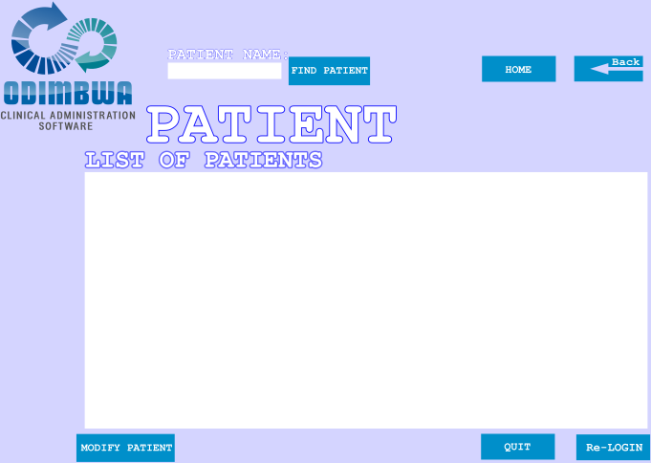

* + 1. Patient Modification Form

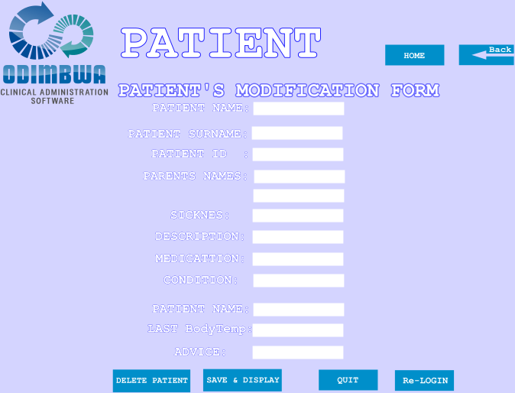

1. User

4.1 User head page

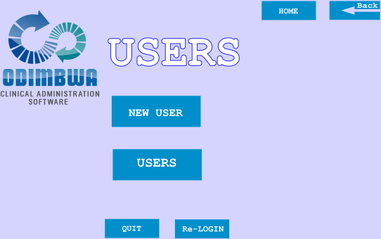

4.2 New User

4.2.1 User Fill Form

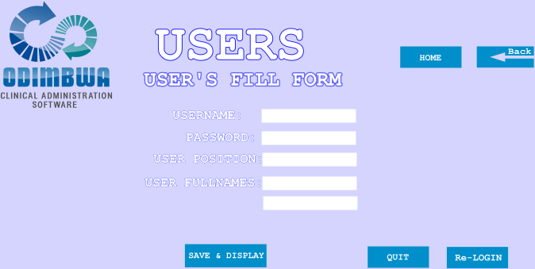

* 1. Usual Users
     1. Usual User Display

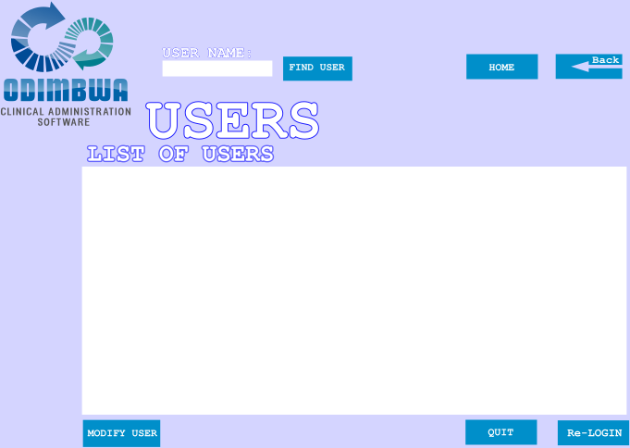

4.3.2 Usual User Modification Form

